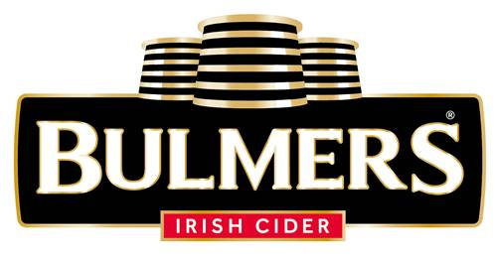

**Brewer – Clonmel**

Bulmers Limited is a member of the C&C Group plc in Ireland and is a major force in the Irish drinks market. The Company markets an extensive portfolio of brand leaders, which includes Bulmers Original Irish Cider.

Based in Clonmel, County Tipperary since 1935, the Company’s people, values and culture have been instrumental in the success of the business to date. As a result of the development of a new Craft Brewery in Clonmel, this exciting opportunity has arisen. Reporting to the Process Manager, you will be responsible for all end to end brewing operations.

**The key responsibilities for this role include:**

* Daily operation of the Craft Brewery.
* Become part of the Clonmel craft brewery, bringing your knowledge and creativity to generate a buzz in an exciting range of innovative craft beers.
* Become part of a small multi-skilled team such that can independently run and maintain the brewery, achieving excellence in all aspects of craft beer production.
* Ensuring a consistently high quality product is produced on time in full and to budget.
* Ensure daily, weekly and monthly production targets are achieved.
* Participate in the comprehensive program of continuous improvement in place to improve quality, performance, efficiency and reduce costs.
* Effectively and efficiently operating and monitoring processes and operations including basic plant maintenance and recording and analysis of plant data.
* Identify preventative maintenance needs and participate in annual overhauls of key brewing kit.
* Responsibility for all aspects of Health & Safety, Quality and Production and ensure compliance to legislation and commitment to quality. Comply with all SHE, Quality, Technical and Food Safety requirements and standards.
* Involved in the creation of a range of new craft beers.
* Take overall responsibility for all brewing equipment used while carrying out role, including responsibility for plant hygiene, safety and quality standards.
* Monitor brewery budgets ensuring raw material and ingredient stocks are maintained and records kept up to date. Reconciliation of all liquids stocks.
* Ensure timely and accurate completion of documentation and system transactions required to operate, meet customer requirements and improve performance in the brewery.
* Undertake training in line with business needs in order to continually develop skills and knowledge to meet the demands of the business now and in the future.
* Ensure that all assigned projects are fully completed on time and to budget.
* Contribute to maximising performance by undertaking any reasonable request where it is safe to do so and skills and knowledge permit.

**The Candidate:**

* IBD Certification in Brewing or equivalent
* A knowledge of food and production processes is required as well as a high awareness of required brewery hygiene standards
* Excellent team player, able to develop strong relationships with colleagues and peers
* Ability to self-manage and make and implement decisions in the absence of supervision
* be comfortable working in a fast-paced environment, and have an enthusiastic, can do/will do approach to their work.

Ideal candidates should be flexible, highly motivated and committed with the ability to deliver results by taking the initiative and taking pride in consistently delivering high quality work on time. Have the ability to work with colleagues across the site and demonstrate a strong motivation towards teamwork. Be a self starter, a quick learner and have a positive and enthusiastic attitude to drive a culture of continuous improvement.